

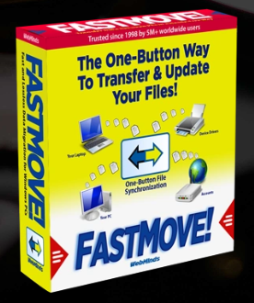

WebMinds, Inc.

TM

Version v1.0

Version

Copyright © WebMinds, Inc., 2024

All Rights Reserved

This publication is protected by federal copyright law. No part of this publication may be copied or distributed, stored in a retrieval system, or translated into any human or computer language in any form or by any means, electronic, mechanical, magnetic, manual or otherwise, or disclosed to third parties without the express written permission of **WebMinds, Inc.**

**WebMinds, Inc.** makes no representation or warranties with respect to the contents hereof and specifically disclaim any implied warranties of merchantability or fitness for a particular purpose. Further, **WebMinds, Inc.** reserves the right to revise this publication and to make changes from time to time in the contents hereof without obligation of **WebMinds, Inc.** to notify any person or organization of such revision or changes.

**WebMinds, Inc.** has prepared this guide for use by **WebMinds, Inc.** personnel and authorized third parties as a guide to proper operation and/or maintenance of **WebMinds, Inc.** equipment and software. The drawings and specifications contained herein are the property of **WebMinds, Inc.**

Trademarked names may appear throughout this user manual. Rather than list the names and entities that own the trademarks or insert a trademark symbol with each mention of the trademarked name, the names are used only for editorial purposes and to the benefit of the trademark owner with no intention of infringing upon that trademark.

Address comments and corrections to:

**WebMinds, Inc.**

950 N Collier Blvd. Suite 400

Marco Island FL 34145

USA

Revision History

|  |  |  |  |
| --- | --- | --- | --- |
| Date | Release | Revision DESCRIPTION | MODIFIED BY |
| Jan 16, 2024 | 0.1 | Initial draft | David A. Flynn |
| Jan 25, 2024 | 1.0 | First base lined user manual | David A. Flynn |
|  |  |  |  |
|  |  |  |  |
|  |  |  |  |
|  |  |  |  |

About this User Manual

This user manual contains information about the all features & functionalities of the FastMoveTM application and instructions on how to use them.

Purpose of this User Manual

The purpose of this user manual is to assist the end users of the TM application.

In Scope of this User Manual

The scope of this user manual includes the description and usage of the TM application.

Out of Scope of this User Manual

The scope of this user manual does not include –

* the detailed installation process of TM application
* the usage of the features and functionalities of your operating system

Intended Audience of this User Manual

The intended audiences of this user manual are –

* end users of the TM application

Organization of this User Manual

This user manual contains 10 chapters & 1 appendices as indicated below –

|  |  |
| --- | --- |
| chapter | Description |
| **Chapter 1** | Introduction |
| **Chapter 2** | Getting Started |
| **Chapter 3** | Using the Auto Mode |
| **Chapter 4** | Using the Advanced Mode |
| **Chapter 5** | Viewing the Wi-Fi Passwords |
| **Chapter 6** | Using the Browser Cleanup Feature |
| **Chapter 7** | Using the Speed Test Feature |
| **Chapter 8** | Using the Diagnostic Troubleshooting Feature |
| **Chapter 9** | Activating your FastMove TM Installation |
| **Chapter 10** | Removing your FastMove TM License Key |
| **Appendix A** | Frequently Asked Questions |

Typographical Conventions / Customaries used in this User Manual

The typographical conventions used in this user manual include the following –

* **Note:** The purpose of this typographical convention is to provide important information corresponding to an already stated fact. This is how we depict a note in this user manual –

**Note:**<Note Text><Note Text><Note Text><Note Text><Note Text><Note Text><Note Text><Note Text><Note Text><Note Text><Note Text><Note Text><Note Text><Note Text>

* **Tip:** The purpose of this typographical convention is to provide additional information supplementing an already stated fact. This is how we depict a tip in this user manual –

**Tip:**<Tip Text><Tip Text><Tip Text><Tip Text><Tip Text><Tip Text><Tip Text><Tip Text><Tip Text><Tip Text><Tip Text><Tip Text><Tip Text><Tip Text><Tip Text><Tip Text><Tip Text>

* **Warning:** The purpose of this typographical convention is to provide critical information corresponding to an already stated fact. This is how we depict a warning in this user manual –

**Warning:**<Warning Text><Warning Text><Warning Text><Warning Text><Warning Text><Warning Text><Warning Text><Warning Text><Warning Text><Warning Text><Warning Text>

* **Reference:** The purpose of this typographical convention is to refer you to another section in this user manual or another document or to an external reference. A reference is depicted in the following manner in this user manual –

**Reference:** To read detailed steps, navigate to **<Chapter Name>** chapter by clicking this link.

or

**Reference:** For more information, navigate to **<Chapter Name>** chapter by clicking this link.

Abbreviations / Acronyms used in this User Manual

The table below describes the abbreviations / acronyms used in this user manual –

|  |  |
| --- | --- |
| Abbreviation | Description |
| **GUI, UI** | Graphical User Interface, User Interface |
| **IPR** | Intellectual Property Rights |
| **NO** | FastMove |
| **TM** | Trade Mark |
| **TOC, TOT, TOF** | Table of Contents, Table of Tables, Table of Figures |
| **PC** | Personal Computer |
| **FAQs** | Frequently Asked Questions |

Terms Used in this User Manual

The below table briefly describes the terms utilized in this user manual –

| chapter | Description |
| --- | --- |
| **End User** | An operator or user of the FastMove TM application. |

Table of Contents

Revision History ii

About this User Manual iii

Purpose of this User Manual iii

In Scope of this User Manual iii

Out of Scope of this User Manual iii

Intended Audience of this User Manual iii

Organization of this User Manual iii

Typographical Conventions / Customaries used in this User Manual iv

Abbreviations / Acronyms used in this User Manual v

Terms Used in this User Manual v

Table of Contents 6

Table of Figures 7

Chapter - 1. Introduction 8

1.1 Downloading the FastMoveTM Application Installer 8

Chapter - 2. Planning your Data Movement 9

Chapter - 3. Placing a Register Request 10

3.1 Via the FastMoveTM Homepage 10

3.2 Via the Register Button of FastMoveTM Application 12

Chapter - 4. Placing a Buy Now Request 14

Chapter - 5. Getting Started 16

Chapter - 6. Performing Offline Data Migration 17

Chapter - 7. Performing Online Data Migration 22

Chapter - 8. Activating your FastMoveTM Installation 27

Chapter - 9. Removing your FastMoveTM License Key 30

Appendix - A. Frequently Asked Questions (FAQs) 32

Index 36

Table of Figures

Figure 1 – Downloading the FastMoveTM application installer executable file 8

Figure 2 – Placing a register request via the FastMoveTM homepage 10

Figure 3 – Specifying your registration details 10

Figure 4 – Secure cart checkout page 11

Figure 5 – Reaching the Register button in the FastMoveTM application – step 1 12

Figure 6 – Reaching the Register button in the FastMoveTM application – step 2 12

Figure 7 – Reaching the Register button in the FastMoveTM application – step 3 13

Figure 8 – Reaching the Register button in the FastMoveTM application – step 4 13

Figure 9 – Placing a buy now request via the FastMoveTM homepage 14

Figure 10 – Secure cart checkout page 15

Figure 11 – FastMoveTM default screen 16

Figure 12 – Performing offline data migration 17

Figure 13 – Selecting a folder 17

Figure 14 – Exporting you data folders & files 18

Figure 15 – Performing offline data migration 19

Figure 16 – Selecting a folder 19

Figure 17 – Importing your data files & folders 20

Figure 18 – Performing online data migration – PC1 22

Figure 18 – Performing online data migration – PC2 23

Figure 18 – Performing online data migration – PC2 23

Figure 19 – Specifying the IP Adress of your second or newer PC 24

Figure 19 – Specifying the data folders & files to migrate from your first or older PC to your second or newer PC 24

Figure 20 – Importing your data folders & files 25

Figure 20 – Selected data folders & files 25

Figure 20 – Selected data folders & files 26

Figure 24 – Activating your FastMoveTM Installation 27

Figure 25 – Key application popup 28

Figure 26 – Successful application of your license key 29

Figure 27 – Viewing your license key details 29

Figure 28 – Removing your FastMoveTM License Key 30

Figure 29 – Viewing your license key details 30

Figure 30 – License key deactivation confirmation message 31

Figure 31 – License key deactivation successfully status message 31

# Introduction

Whether you're transferring data between computers sharing the same OS version, moving files, & settings from a Windows 7 to a Windows 11 PC, or migrating from a 32-bit to a 64-bit system, FastMoveTM is here to do the job. Using FastMoveTM to transfer data is very easy. Just connect both PCs to the network, select what you want to transfer, let FastMoveTM do the rest!

**Reference:** To view our FastMoveTM promotional video, visit <https://youtu.be/5ZBATakz8JA>

Downloading the FastMoveTM Application Installer

You can download the FastMove TM application from the **Download** link available in the menu on the FastMove TM homepage as depicted in the figure below –

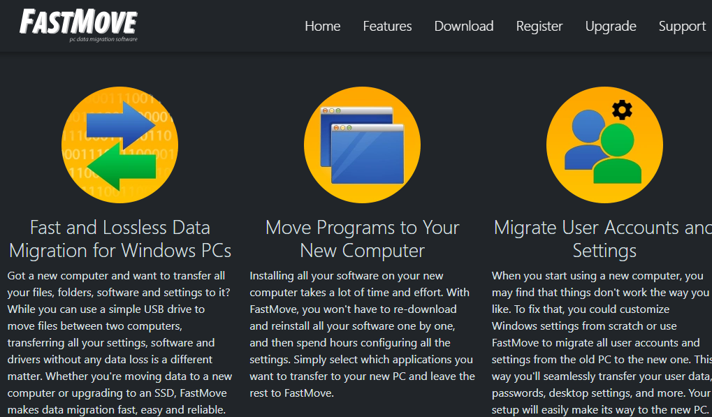

Figure – Downloading the FastMoveTM application installer executable file

**Tip:** After you click the above-mentioned links, you may be warned by your web-browser about a potential security risk due to the downloaded executable file. Please authorize this file.

You can follow the installation wizard by launching the downloaded FastMove TM installer executable file to install the FastMove TM application on both your systems.

**Tip:** After you open the downloaded executable file, you may be warned by your operating system before you can install this application on your system. Please authorize your operating system to continue installing this application at this step.

The next chapter describes steps that enable you to plan your data movement with the FastMove TM application.

# Planning your Data Movement

Since you may have just downloaded the FastMove TM installer executable file & installed this application, it is understandable that you may not have purchased a FastMove TM License Key and Registered it on both PCs as yet.

Before we go ahead, we require considering a few points as described below –

* This application will only **allow you to transfer your data files** using the **Custom Files** mode only in both the offline and online modes.
* You will not be able **to transfer your users, software, device drivers, favorites, or sync your folders** in the unregistered mode.

**Tip:** These features are only available in the registered mode.

* Also, while utilizing the offline mode, in both the registered & unregistered modes, you will also require **planning the amount of data you are expecting to move**. This is because you will require **a USB drive with enough empty storage to manually move the data between your two PCs**.
* Also, consider the scenario in the registered mode that if you are **trying to move your software from a 32-bit operating system to a 64-bit operating system**, most programs made for the **32-bit version of Windows will work on the 64-bit version of Windows except for most Antivirus programs**. Though you must **consider checking with your software manufacturers** before you make such a software movement as some of your applications may not work.

**Tip:** We highly recommend that you place a **Buy Now** or **Register** request while you test the **Custom Files** mode to save time and the least iterations of data movement.

The next chapter describes steps that enable you to **Place a Register Request** with us before you test the **Custom Files** mode the FastMove TM application. This will enable you to save time and reduce the number of iterations of your data movement.

# Placing a Register Request

You can place a **Register** request in the following 2 ways –

## Via the FastMoveTM Homepage

The steps described below enable you to place a register request of the FastMoveTM application via the FastMoveTM homepage –

1. From the FastMove TM homepage, click the **Register** link available in the menu on the FastMove TM homepage as depicted in the figure below –



Figure – Placing a register request via the FastMoveTM homepage

1. Click the **Register** as depicted in the figure above. The register your software form is displayed as depicted in the figure below –

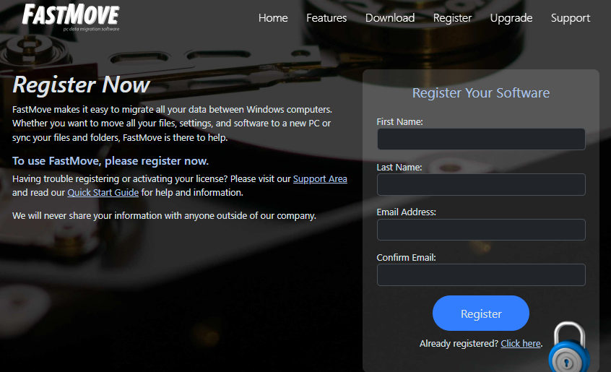

Figure – Specifying your registration details

1. Specify your first name, last name, your email address, then confirm your email address & click **Register**. The secure cart checkout page is displayed as depicted in the figure below –

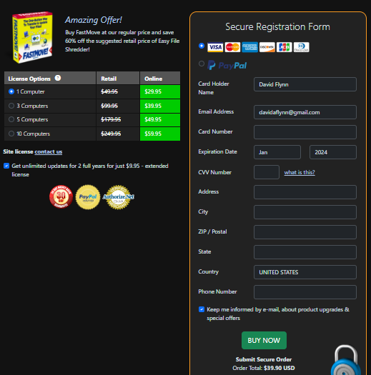

Figure – Secure cart checkout page

1. Specify the required license options and your payment details & click **Buy Now**.

**Warning:** Ensure to double-check your specified details before you click **Buy Now**.

1. Once your payment details have been successfully processed, you will receive an email containing your FastMoveTM license key.

## Via the Register Button of FastMoveTM Application

The steps described below enable you to place a register request of the FastMoveTM application via the Register Button of FastMoveTM application –

1. After you launch the FastMoveTM application, the default screen is displayed as depicted in the figure below –

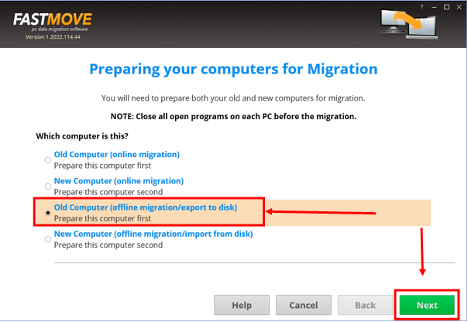

Figure – Reaching the Register button in the FastMoveTM application – step 1

1. Select the **Old Computer (offline migration/export to disk)** option & click **Next**. The folder specification page is displayed as depicted in the figure below –

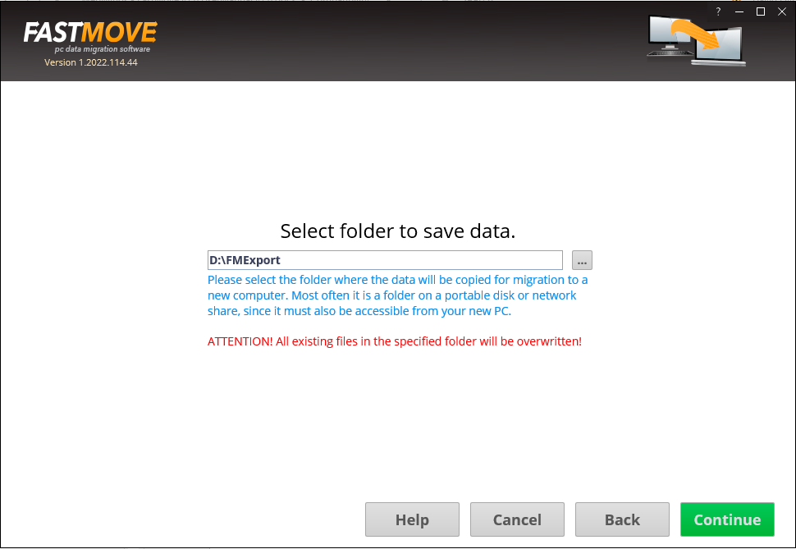

Figure – Reaching the Register button in the FastMoveTM application – step 2

1. Specify the folder to export your data by using the **Ellipsis (…)** button & click **Continue**. The custom file page is displayed as depicted in the figure below –

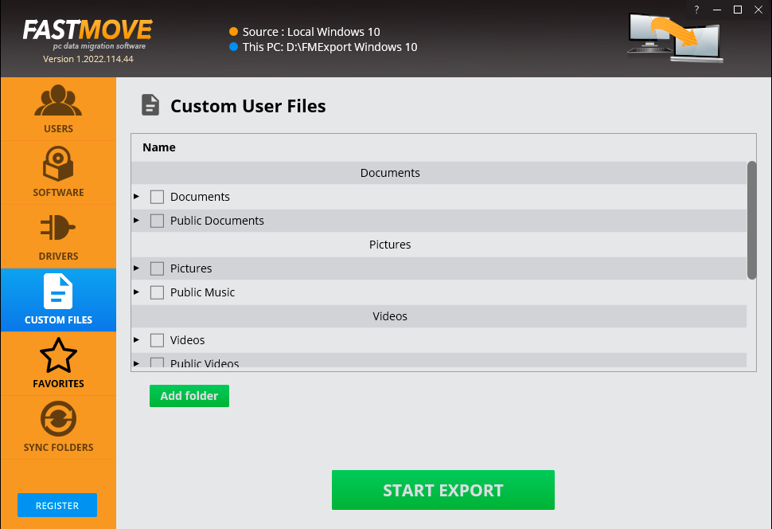

Figure – Reaching the Register button in the FastMoveTM application – step 3

1. Click the **Register** button as depicted in the figure above. The license registration key popup is displayed as depicted in the figure below –

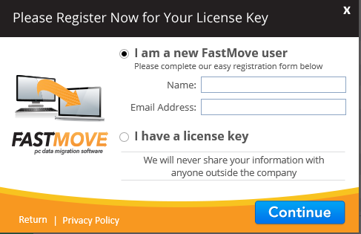

Figure – Reaching the Register button in the FastMoveTM application – step 4

1. Specify your Name & Email Address and click **Continue**. You will be redirected to the FastMoveTM Support page after which you can click Upgrade, specify a subscription plan of your choice, and make your payment. Post this, we will send you your license key on the email address that you specified on the registration popup.

The next chapter describes steps that enable you to Place a Buy Now request for a FastMove TM application key.

# Placing a Buy Now Request

The steps described below enable you to place a **Buy Now** request of the FastMoveTM application via the FastMoveTM homepage –

1. Open the FastMove TM homepage. The FastMove TM homepage is displayed as depicted in the figure below –

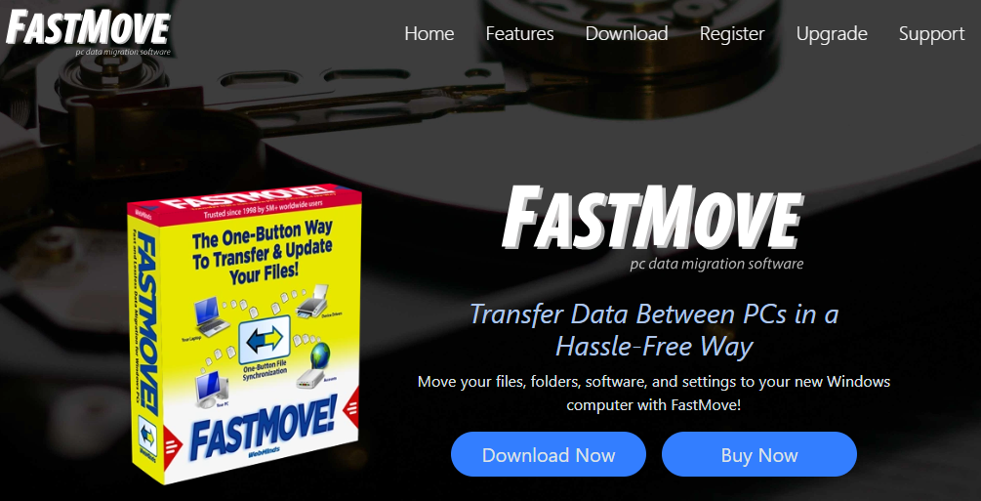

Figure – Placing a buy now request via the FastMoveTM homepage

1. Click the **Buy Now** as depicted in the figure above. The secure cart checkout page is displayed as depicted in the figure below –



Figure – Secure cart checkout page

1. Specify the required license options and your payment details & click **Buy Now**.

**Warning:** Ensure to double-check your specified details before you click **Buy Now**.

1. Once your payment details have been successfully processed, you will receive an email containing your FastMoveTM license key.

The next chapter describes steps that enable you to **Get Started** with the FastMove TM application.

# Getting Started

After you launch the FastMoveTM application, the default screen is displayed as depicted in the figure below –

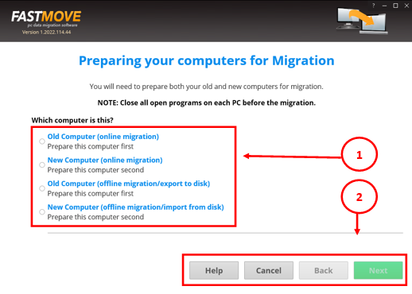

Figure – FastMoveTM default screen

Below is a description of the screen elements of the default screen of the TM application.

| **NO.** | **DESCRIPTION** |
| --- | --- |
| **1** | This section of the screen provides radio buttons to select the one the appropriate action depending on the computers. The FastMoveTM application allows to do both online and offline data, device drivers, your installed software with Zero Fault Loss Data movement in the **Registered** mode.  **Reference:** To read the detailed steps, navigate to **Activating your FastMoveTM Installation** chapter by clicking this link. |
| **2** | Clicking **Help** opens this User Manual. Clicking **Cancel** close the FastMove TM application. Clicking **Back** enables you to revert to the previous step as you advance in the wizard.  **Reference:** To read the detailed steps, navigate to **Activating your FastMoveTM Installation** chapter by clicking this link. |

The next chapter describes steps that enable you to perform offline data migration.

# Performing Offline Data Migration

The steps described below enable you to perform offline data migration –

1. After you launch the FastMoveTM application on your first or older PC, the default screen is displayed as depicted in the figure below –



Figure – Performing offline data migration

1. Select the **Old Computer (offline migration/export to disk)** option & click **Next**. The folder specification page is displayed as depicted in the figure below –



Figure – Selecting a folder

**Tip:** Typically, this will be your external storage location.

1. Specify the folder to export your data by using the **Ellipsis (…)** button & click **Continue**. The custom file page is displayed as depicted in the figure below –



Figure – Exporting you data folders & files

1. Select the folders that you intend to export and click **Start Export**.

Tip: You can specify more folders in case they are not available in this list by clicking **Add Export**.

The specified folder will be exported to the external storage location that you specified in step 2 in this section.

1. Now attach your external storage location to your second PC and launch the FastMoveTM application.
2. After you launch the FastMoveTM application on your second or newer PC, the default screen is displayed as depicted in the figure below –

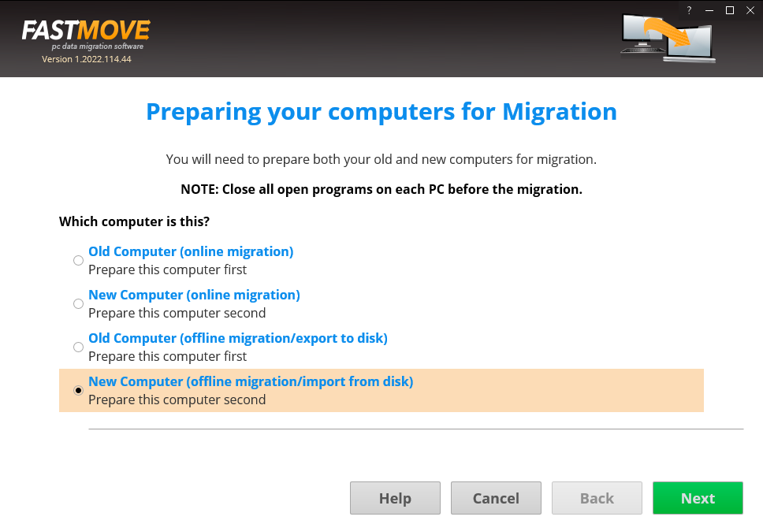

Figure 15 – Performing offline data migration

1. Select the **New Computer (offline migration/import from disk)** option & click **Next**. The folder specification page is displayed as depicted in the figure below –

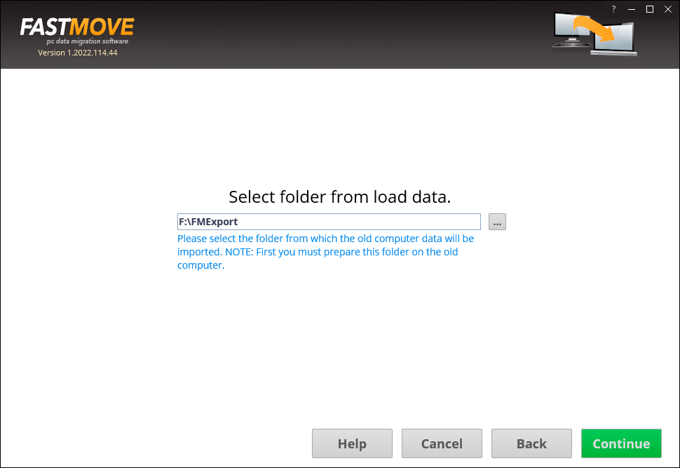

Figure 16 – Selecting a folder

**Tip:** Typically, this will be your external storage location.

1. Specify the folder to import your data from by using the **Ellipsis (…)** button & click **Continue**. The custom file page is displayed as depicted in the figure below –

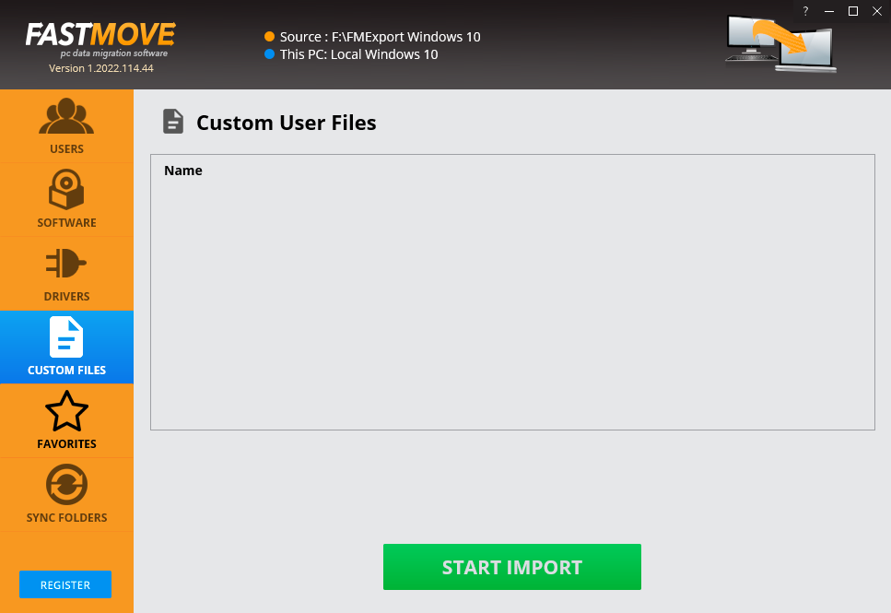

Figure 17 – Importing your data files & folders

1. Click **Start Import**. The specified folder will be imported to you second or new PC and a confirmation message will also be displayed.

**Tip:** Your files will be imported at the same path as your first or older PC.

The next chapter describes steps that enable you to **Perform Online Data Migration**.

# Performing Online Data Migration

The steps described below enable you to perform online data migration –

1. Connect both your old & new PCs to the same network.

**Tip:** Ensure that both these PCs are discoverable to each other. Consult your network administrator or Windows Support. You may also require ensuring that you allow FastMoveTM through the Windows Firewall on both PCs.

1. After you launch the FastMoveTM application on your first or older PC, the default screen is displayed as depicted in the figure below –

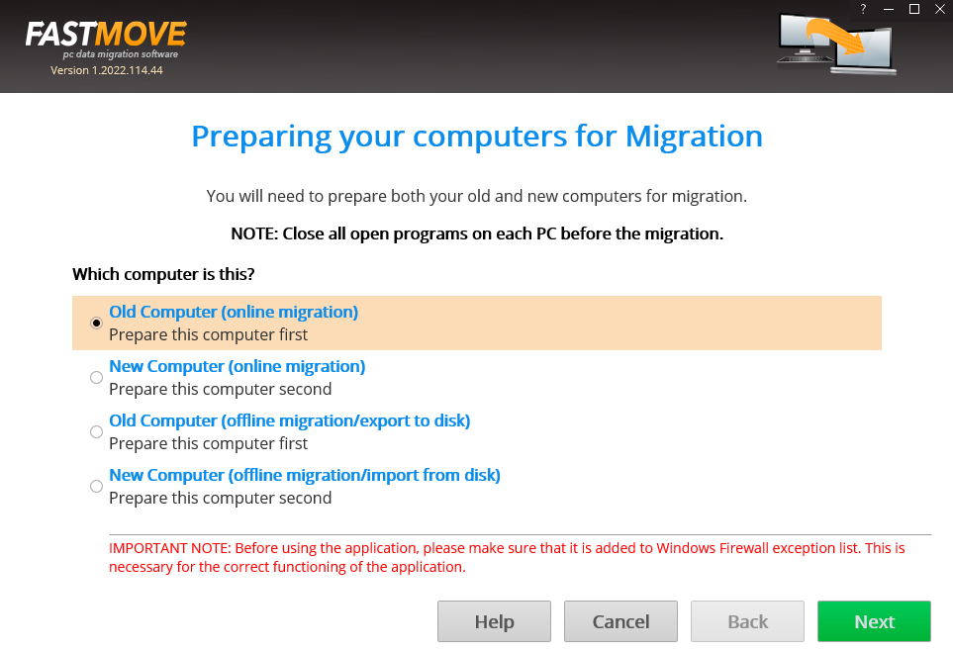

Figure 18 – Performing online data migration – PC1

1. Select the **Old Computer (offline migration/export to disk)** option on the first or old PC & click **Next**. Your IP Address details page is displayed as depicted in the figure below –

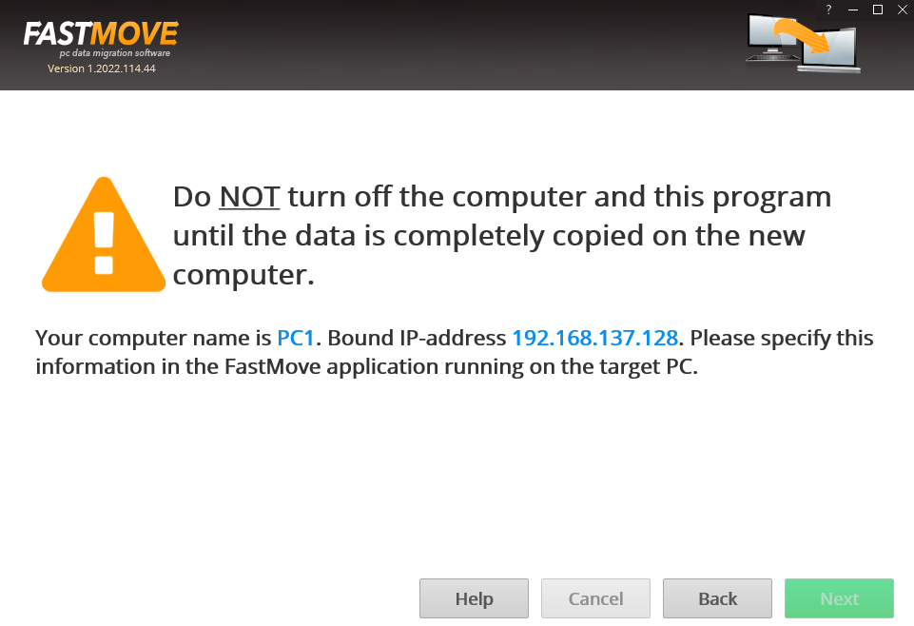

Figure 19 – Performing online data migration – PC2

1. Now on your second or newer PC, select the **New Computer (online migration)** option & click **Next** from the default screen is displayed as depicted in the figure below –

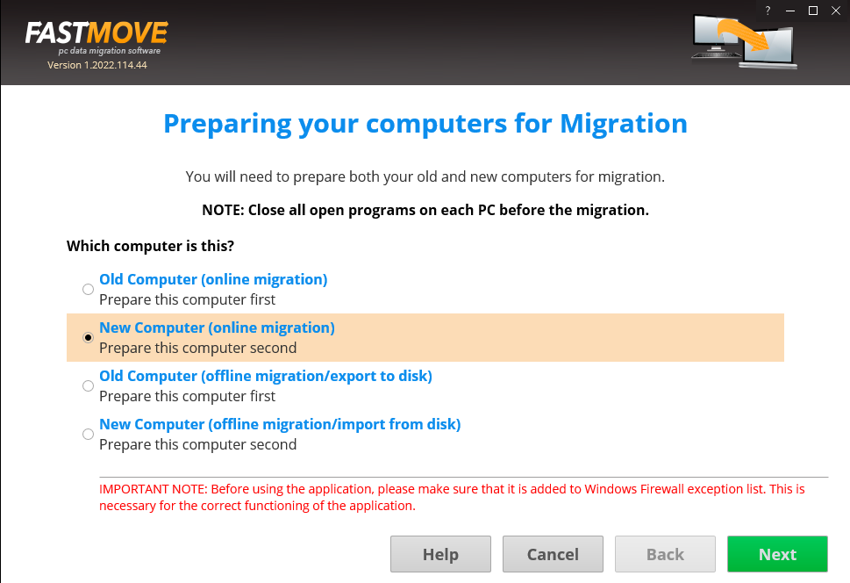

Figure 20 – Performing online data migration – PC2

The FastMoveTM application will scan your network in order to look for your first or old PC automatically.

1. After your network has been successfully scanned, the IP Address details specification windows will be displayed as depicted in the figure below –

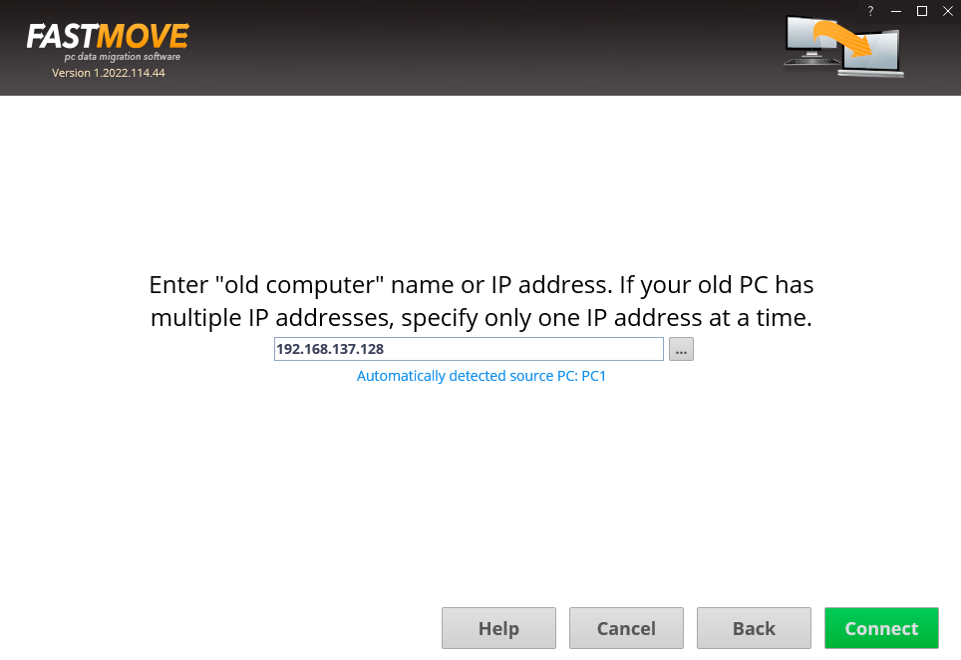

Figure 21 – Specifying the IP Adress of your second or newer PC

**Tip:** In case you do not see an automatically detected PC, consult your network administrator or Windows Support. You can also specify another IP Address in case you have multiple PCs connected to your network via the FastMoveTM application by clicking the **Ellipses (…)** button.

1. Click **Connect**. The custom files window is displayed a depicted in the figure below –

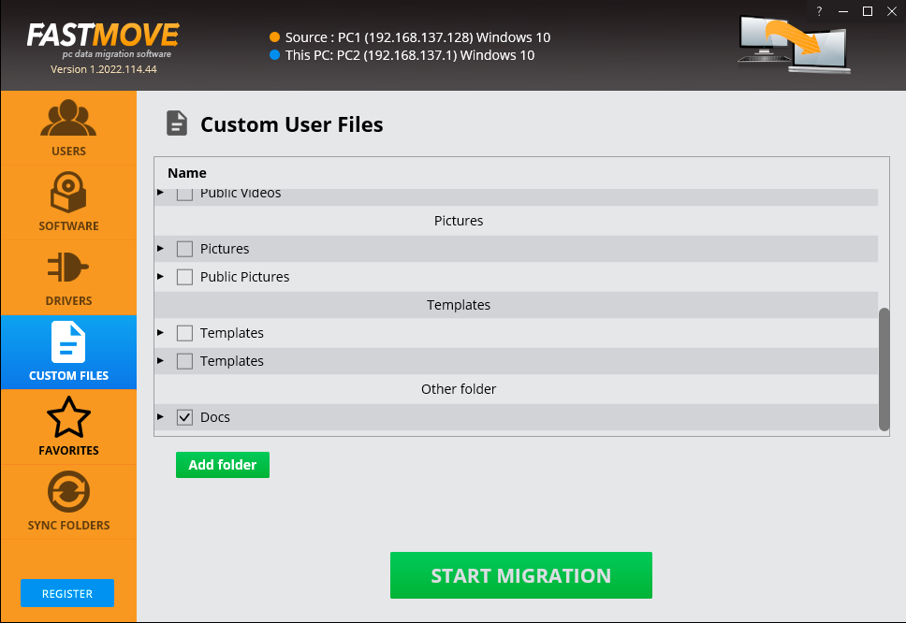

Figure 22 – Specifying the data folders & files to migrate from your first or older PC to your second or newer PC

1. Specify the folder to import your data from this dialog box or by clicking **Add Folder** button. The custom file page is displayed as depicted in the figure below –

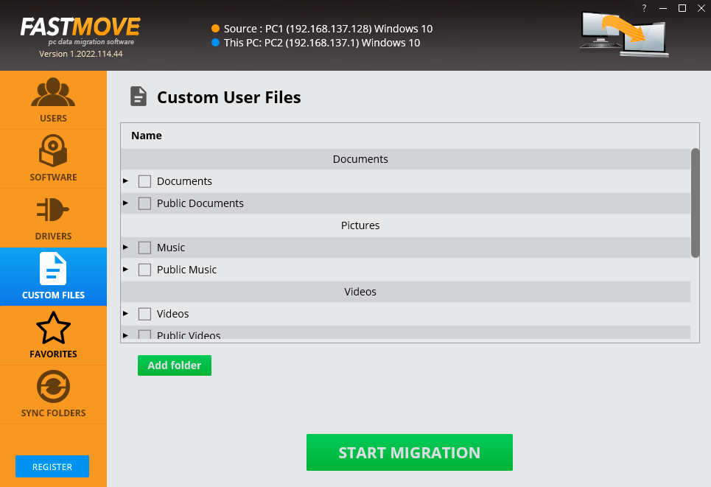

Figure 23 – Importing your data folders & files

Your files will be selected as depicted in the figure below –



Figure 24 – Selected data folders & files

1. Click **Start Migration**. Your data folders & files will be migrated and a confirmation message will be displayed as depicted in the figure below –

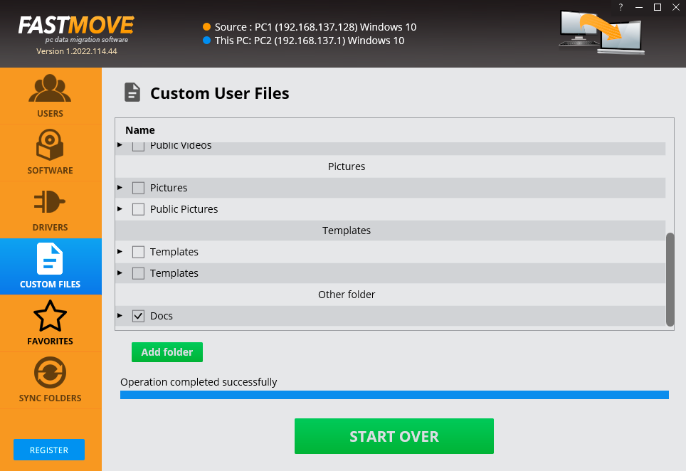

Figure 25 – Selected data folders & files

**Tip:** You can click **Start Over** to specify more data folders or files.

The next chapter describes steps that enable you to Activate your FastMoveTM installation.

# Activating your FastMoveTM Installation

In case you have not activated your FastMoveTM application as yet, you can utilize the steps described below –

1. Launch the FastMoveTM application by clicking the Desktop shortcut of this application. The FastMoveTM default screen is displayed as depicted in the figure below –

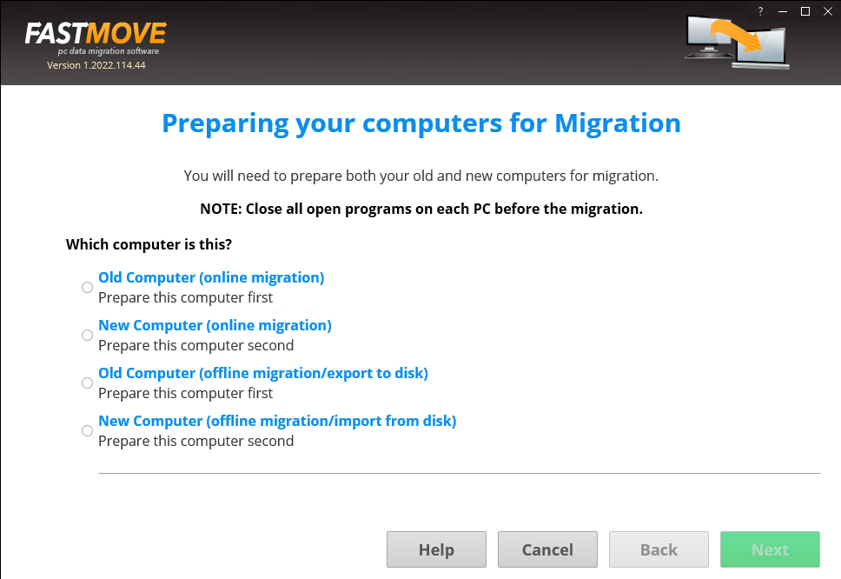

1. From the default screen of the FastMoveTM application, click the **Activate Now** button as depicted in the figure below.

Figure – Activating your FastMoveTM Installation

The Key Application popup is displayed as depicted in the figure below –

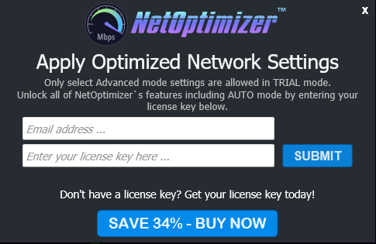

Figure – Key application popup

1. Click the **Buy Now** button to avail the money saving offer depicted here.

**Tip:** You will be navigated to the FastMoveTM shopping cart web page in your default web browser. You can specify the required details, and click **Buy Now** on this web page to make your purchase. You will receive an email containing your license key details at the email address specified by you on this web page.

1. Once you have received your license key, specify your email address and license key and click the **Submit** button. After successful validation of the specified key, your FastMoveTM installation will be activated and a popup will be displayed confirming the same as depicted in the figure below –

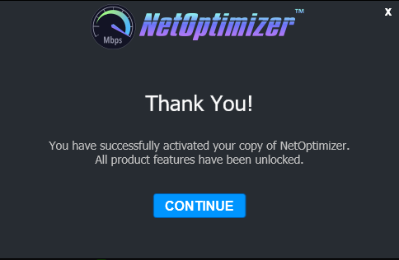

Figure – Successful application of your license key

1. Click **Continue** to continue using the FastMoveTM application. The Activate Now button will be removed from the FastMoveTM default screen.

**Tip:** To view the license details, you can click the **Question Mark (?)** button on the FastMoveTM default screen.

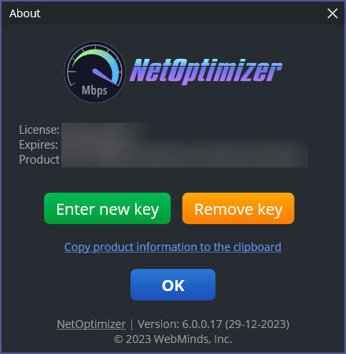

Figure – Viewing your license key details

1. Click **Enter New Key** in case you intend to specify a new license key or click **OK** to continue using the FastMoveTM application.

**Tip:** Click the **Copy product information to the clipboard** link to copy the license details. You can paste this key in a document of your choice for safekeeping.

The next chapter describes steps that enable you to Remove your FastMoveTM license key.

# Removing your FastMoveTM License Key

Once you have activated your FastMoveTM application with a valid license key which has not expired yet, you can utilize the steps described below which enable you to remove this key so that you can reuse it on another system or the same system at a later date provided it has not expired –

1. From the default screen of the FastMoveTM application, click the **Question Mark (?)** button as depicted in the figure below.

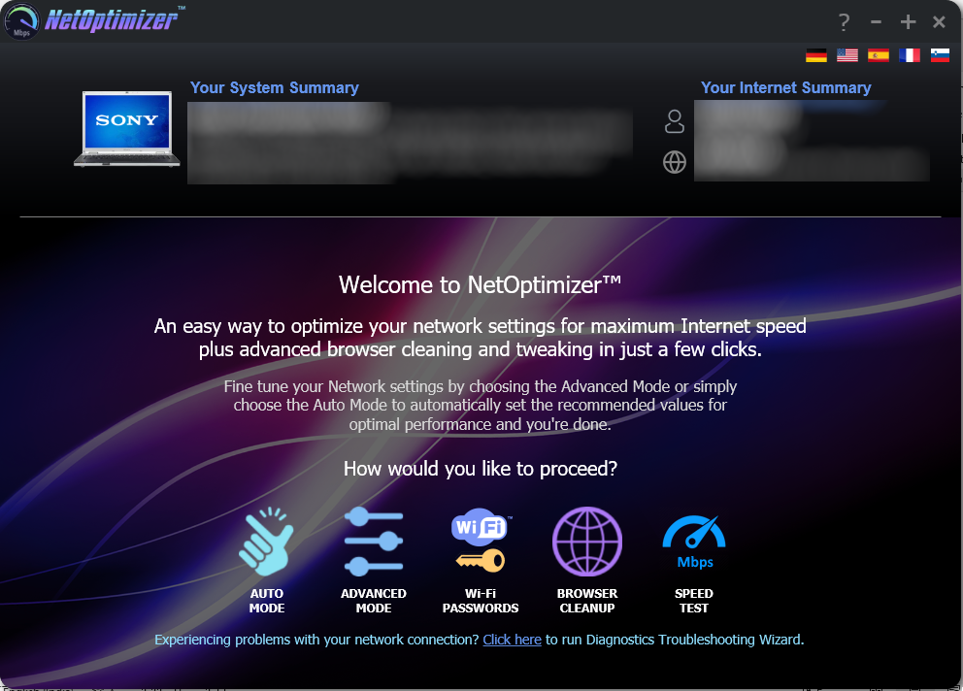

Figure – Removing your FastMoveTM License Key

The About popup is displayed as depicted in the figure below –



Figure – Viewing your license key details

1. Click **Remove Key** to remove your license key.

**Tip:** Click the **Copy product information to the clipboard** link to copy the license details. You can paste this key in a document of your choice for safekeeping.

1. After you have clicked on **Remove Key**, the application will query you for your confirmation as depicted in the figure below –

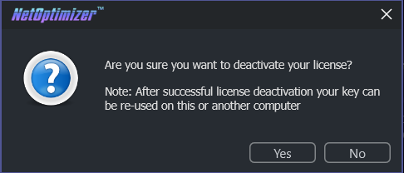

Figure – License key deactivation confirmation message

1. Click **Yes** to continue to deactivating your license key or click **No** to continue using your already specified license key. If you clicked **Yes**, a deactivation successful status message will be displayed as depicted in the figure below –

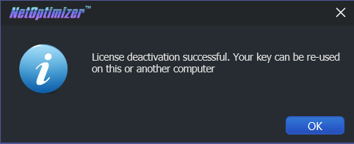

Figure – License key deactivation successfully status message

1. Click **Ok** to continue using the FastMoveTM application.

The next section of this user manual **Frequently Asked Questions (FAQs)** as an appendix.

1. Frequently Asked Questions (FAQs)

Here is a list of frequently asked questions with reference to the FastMoveTM application and its usage –

How can FastMove™ help me?

FastMoveTM is an advanced system utility that checks your computer for non-optimal Internet connection settings and enables you to apply the best possible settings for your connection type automatically. With its help, you’ll be able to fine-tune your PC to get the actual connection speed as advertised by your Internet service provider.

Do I need to install FastMove™ on my computer?

Yes. After you have downloaded the single-click executable .exe file from the below link, you can install the application by following the easy-to-use installation wizard.

**Reference:** To download the FastMoveTM application installer, click the following link – https://www.FastMove.com/files/FastMove.exe. The system may prompt you to restart itself to finish installing the FastMoveTM application. Please save your work and restart your system at this point.

What are the minimum system requirements for FastMove™?

The minimum system requirements for FastMoveTM are:

* Windows XP SP3 or newer
* 1 GHz CPU (both 32-bit and 64-bit platforms are supported)
* 128 MB RAM
* 32 MB disk space
* Screen size of 1024×768 or larger

Which versions of Windows is FastMove™ compatible with?

FastMoveTM is compatible with the following versions of Windows –

* Windows XP
* Windows Vista
* Windows 7
* Windows 8
* Windows 10
* Windows 11

Which settings can I optimize with FastMove™?

FastMoveTM fine-tunes hidden Windows network settings such as TCP settings, TTL, I/O parameters, and network efficiency.

**Reference:** For more information, see Error! Reference source not found. chapter.

Does FastMove™ support metered connections?

Yes, FastMoveTM has a special setting for metered connections and can optimize your PC’s network settings for best results on 3G, 4G, and 5G.

How does FastMove™ know the best settings for my computer?

FastMoveTM quickly checks your Internet connection type and your operating system’s parameters to determine if anything needs to be adjusted. If your settings are already optimal, you’ll see green checkmarks next to those settings.

Is FastMove™ safe to use?

Yes, FastMoveTM is absolutely safe to use because you can always undo any changes made by the application by clicking on the **Reset to OS Defaults** button on the **Advanced Mode** screen.

**Reference:** For more information, see Error! Reference source not found. chapter.

What are the trial version limitations?

The trial version of FastMove lets you find the optimal Internet connection settings but it doesn’t let you apply & save them. For that, you’ll need to purchase a license.

**Reference:** For more information, click the **Buy Now** button on the [**FastMoveTM official website**](https://www.netoptimizer.com/) page header or use this link – [https://www.FastMove.com/cart/](https://www.netoptimizer.com/cart/)

Why is there an expiration date on my FastMoveTM license?

When you purchase a license for FastMoveTM, the license unlocks the program forever, so that you can use FastMove for as long as you want. As for the expiry date, it’s set to show you the period during which you will be able to download free updates. Once the license expires, you can continue using your version of the program, but you will need to extend your license to continue getting updates and have access to email support.

**Tip:** Remember that each computer is assigned a unique license ID. Once activated, this license will not work on any other computer while it is being used on a given system provided it is still valid.

Can I reuse my license on another system?

Yes. You can reuse you existing valid license on another system but you will first require removing it from the system it is being used currently.

**Tip:** For more information, see **Removing your FastMoveTM License Key** & **Activating your FastMoveTM Installation** chapters.

**Warning:** Ensure to remove your existing valid license before resetting or reformatting your current Windows installation.

I’m trying to register FastMove but it’s not working. What to do?

There may be a few issues that may prevent the activation of the product, including:

Your UAC (User Account Control) settings in Windows Vista, Windows 7, Windows 8, Windows 10 and Windows 11. When that’s the case, close FastMoveTM, then right-click on its shortcut on your desktop and select **Run as administrator**. Then proceed to register the program.

Your firewall or anti-virus programs may be preventing changes to your computer. Even the changes such as registering your product. Try disabling your security software temporarily and proceed with product registration.

**Tip:** In case you are still facing issues, please fill the **Get in Touch** form provided on the [**Support**](https://www.netoptimizer.com/support/) page and submit your details along with the issue you are facing. To do so, click the following link – [**https://www.FastMove.com/support/**](https://www.netoptimizer.com/support/)**.** We are more than happy to assist you in using the FastMoveTM application.

The next section of this user manual includes an **Index** of frequently referred terms or phrases with reference to the FastMoveTM application and its usage.

Index

A

Abbreviations / Acronyms used in this User Manual v

About this User Manual iii

Activating your FastMoveTM Installation 27

C

Can I reuse my license on another system? 34

D

Do I need to install FastMove™ on my computer? 32

Does FastMove™ support metered connections? 33

Downloading the FastMoveTM Application Installer 8

F

Frequently Asked Questions (FAQs) 32

G

Getting Started 16

H

How can FastMove™ help me? 32

How does FastMove™ know the best settings for my computer? 33

I

I’m trying to register FastMove but it’s not working. What to do? 35

In Scope of this User Manual iii

Intended Audience of this User Manual iii

Introduction 8

Is FastMove™ safe to use? 33

O

Organization of this User Manual iii

Out of Scope of this User Manual iii

P

Performing Offline Data Migration 17

Performing Online Data Migration 22

Placing a Buy Now Request 14

Placing a Register Request 10

Planning your Data Movement 9

Purpose of this User Manual iii

R

Removing your FastMoveTM License Key 30

T

Terms Used in this User Manual v

Typographical Conventions / Customaries used in this User Manual iv

V

Via the FastMoveTM Default Webpage 10

Via the Register Button of FastMoveTM Application 12

W

What are the minimum system requirements for FastMove™? 32

What are the trial version limitations? 34

Which settings can I optimize with FastMove™? 33

Which versions of Windows is FastMove™ compatible with? 33

Why is there an expiration date on my FastMoveTM license? 34